**Project 01_04_01**

In this project, you will continue working with the ***tuba.js*** and ***tractor.html*** files from the class exercise. You will add error handling to the ***verifyCrops()*** function so users receive an error message if they remove checkmarks from all the crop boxes.

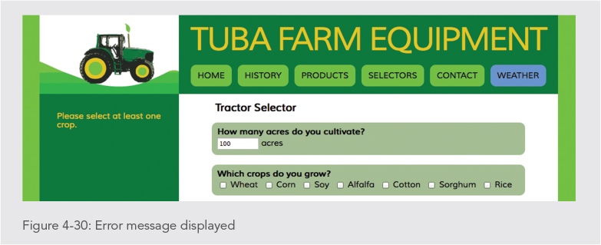 

The code that you will create here is not free of bugs. You will debug the code before submitting for this project. Make sure to add documentation with comments to all of the code you enter, to indicate that you understand it and to explain what it does.

1. Copy all of the completed files from Exercise 01_01_04 into a Project 01_01_04 folder; this will contain all of the files you will zip up and submit. Open all of the necessary files in your IDE and replace ***Exercise 01_04_01*** with ***Project 01_04_01*** in the comments sections.
2. Scroll down to the ***verifyCrops()*** function and replace the ***testFormCompleteness();*** call with the following code:  
    **try {  
    for (var i = 0; i < 7; i++) {  
    if (cropsFieldset.getElementsByTagName("input")[i].checked) {  
    cropscomplete = true;  
    messageElement.innerHTML = "";  
    testFormCompleteness();  
    i = 8;  
    }  
    }  
    if (i === 7) {  
    throw "Please select at least one crop.";  
    }  
    }**Do a browser test at this point, and take a look at the Console. It should indicate that there is a bug. Your ***try*** clause is missing a ***catch*** clause.
3. Below the ***try*** statement, add the following ***catch*** statement:  
    ***catch(message) {  
    cropsComplete = false;  
    messageHeadElement.innerHTML = "";  
    messageElement.innerHTML = message;  
    }***
4. Scroll to the top of the script, and change the values for the variables ***acresComplete***, ***cropsComplete***, and ***monthsComplete*** to ***false***. The value for ***fuelComplete*** should remain ***true***.
5. Run a browser test. Test the crops code by selecting some of them, then deselecting all of them. At this point, you should be getting an error message when no crops are checked. If not, you have a bug in the code you entered and it will need to be fixed before performing any further testing of the form.
6. Now let’s do a complete test of all of the form fields. You should notice that you never get a tractor recommendation. Use the techniques you learned in this Exercise to find the bugs.
7. Hint: even if you do get a recommendation, there may still be another bug. If you turn all crops off, then select one again, you may not get a recommendation. If this is the case, you still have another bug to find.
8. Submit a .zip of all of your files to ***Project 01_04_01***.